Attachment B
Emergency Watershed Protection Program - Floodplain Easement (EWPP-FPE) Option

Floodplain easements restore, protect, maintain, and enhance the functions of the floodplain; conserve natural values including fish and wildlife habitat, water quality, flood water retention, ground water recharge, and open space; reduce long-term federal disaster assistance; and safeguard lives and property from floods, drought, and the products of erosion.

Eligible Land
• Lands damaged by flooding during a specific natural disaster for which Congress allocates EWPP funding, or
• Lands damaged by flooding at least twice during the last 10 years or at least once during the last 12 months, or
• Other floodplain lands that would contribute to the floodplain restoration or improve the practical management of the easement, or
• Lands that would be inundated or adversely impacted as a result of a dam breach.
• Additionally, the land must be privately owned or owned by State or Local Government.

Enrollment Options
- A floodplain easement may be purchased on eligible lands with one of the following uses:

    - Lands on which agriculture or open space is the primary use. These lands may contain structures incidental to the primary use.

    - Lands on which residential use is the primary use and such lands contain residences and other structures. These lands must be part of a strategy for the restoration of an entire floodplain reach. A project sponsor is required to purchase the remaining fee title to the property.

Program Description
• Landowners voluntarily offer to sell to NRCS an easement that provides NRCS with the full authority to restore and enhance the floodplain’s functions and values.

• EWPP Floodplain easements are perpetual, and are held by the United States, through the Secretary of Agriculture
• Removal of buildings is required and may be cost-shared. Removal of other structures or infrastructure as needed to ensure proper functioning of the floodplain is also required and may be cost-shared.
• NRCS may provide up to 100 percent of costs for purchase of the easement and restoration of the floodplain.
• Landowner may participate in restoration efforts


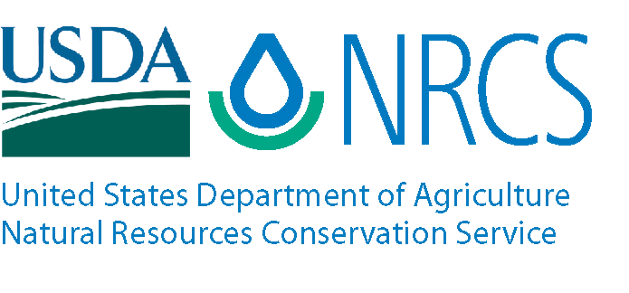
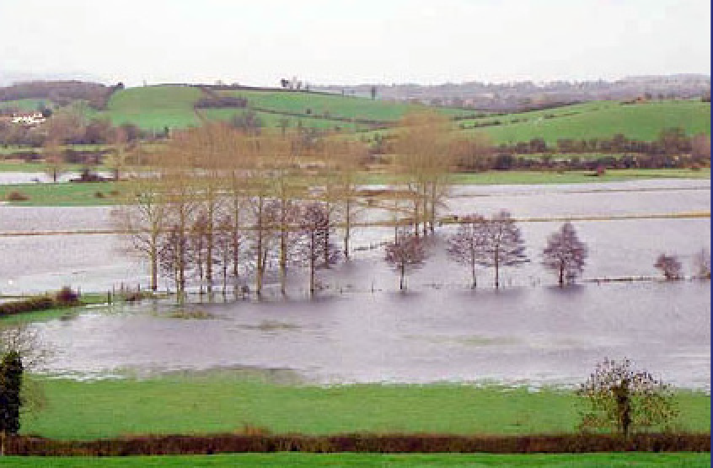
USDA is an equal opportunity provider and employer.

Easement and Restoration Payments
- NRCS may provide up to 100 percent of the restoration costs and easement compensation amount.

- Landowner receives the lowest of one of the three following values as an easement payment:
- the fair market value based on an individual appraisal or for agricultural lands only, an areawide market analysis;
- a corresponding geographic rate established by the NRCS state conservationist; or
- an offer made by the landowner.

- The value of residential structures and the cost for their removal from the floodplain is accounted for in the determination of the easement compensation value or restoration cost-share amounts based on whether the residential structure will be demolished or relocated.

Restoration Practices


      - Floodplains will be restored to natural conditions to the maximum extent practicable.
      - Restoration measures include activities such as reestablishment of permanent vegetative cover and natural floodplain topography
      - Removal (relocation or demolition) of all buildings, and removal of other structures or infrastructure that is not necessary for the proper functioning of the flood plain such as mill dams, dikes, and fences.

Landowner Use
- The owners of the land on which a floodplain easement has been purchased retain limited property rights subject to the terms of the easement including:
- The right to quiet enjoyment,
- The right to control public access, and
- The right to undeveloped recreational use such as hunting and fishing
• Landowners may request temporary authorization from NRCS to engage in other activities, called compatible uses, provided that NRCS determines that such activities will further the protection and enhancement of the easement’s floodplain functions and values.
• Compatible uses may include activities such as mowing for trails, habitat management, managed timber harvest, periodic haying, or grazing.
  - Cropping is not authorized and haying or grazing would not be authorized as a compatible use on lands that are being restored to woody vegetation.
• Compatible uses are only authorized on a temporary basis and NRCS prescribes the amount, method, timing, intensity, and duration of any compatible use that might be authorized.
  - A landowner may realize economic returns from a compatible use activity allowed on the easement area but is not assured of any specific level or frequency of such use, and the authorization does not vest any rights outside of those specified in the easement.
USDA Natural Resources Conservation Service (NRCS) is a federal agency that assists landowners and users with the voluntary implementation of conservation practices to protect and restore natural resources.
For more information contact your local USDA Service Center, or visit us on the web at:

www.nrcs.usda.gov

July 2019

